**FLOOD MONITORING**

## PHASE – 4 DEVELOPMENT

**Creating a real-time flood monitoring Management platform involves a combination of front end and backend technologies. Here’s a simplified outline using C and C++ and python programming with wi-fi connection for the front end and Node.js for the back end:**

**Python:**

**import RPi.GPIO as GPIO**

**import time**

**import paho.mqtt.client as mqtt**

**# GPIO Pins for the ultrasonic sensor**

**TRIG = 23**

**ECHO = 24**

**# MQTT Configuration**

**mqtt_broker = "mqtt.example.com"**

**mqtt_topic = "flood_monitoring"**

**# Initialize GPIO**

**GPIO.setmode(GPIO.BCM)**

**GPIO.setup(TRIG, GPIO.OUT)**

**GPIO.setup(ECHO, GPIO.IN)**

**# Create MQTT client**

**client = mqtt.Client()**

**client.connect(mqtt_broker)**

**def measure_water_level():**

**# Trigger ultrasonic sensor**

**GPIO.output(TRIG, True)**

**time.sleep(0.00001)**

**GPIO.output(TRIG, False)**

**# Measure time for echo**

**while GPIO.input(ECHO) == 0:**

**pulse_start = time.time()**

**while GPIO.input(ECHO) == 1:**

**pulse_end = time.time()**

**# Calculate distance (cm)**

**pulse_duration = pulse_end - pulse_start**

**distance = pulse_duration * 17150**

**return distance**

**try:**

**while True:**

**water_level = measure_water_level()**

**print(f"Water level: {water_level} cm")**

**# Publish data to MQTT**

**client.publish(mqtt_topic, f"Water level: {water_level} cm")**

**time.sleep(10) # Read data every 10 seconds**

**except KeyboardInterrupt:**

**GPIO.cleanup()**

**C program:**

**#include <stdio.h>**

**#include <wiringPi.h> // GPIO library for Raspberry Pi**

**#include <mosquitto.h> // MQTT library**

**#define TRIG 23 // GPIO pin for ultrasonic sensor trigger**

**#define ECHO 24 // GPIO pin for ultrasonic sensor echo**

**// MQTT Configuration**

**const char *mqtt_broker = "mqtt.example.com";**

**const char *mqtt_topic = "flood_monitoring";**

**// Ultrasonic sensor functions**

**void setupUltrasonicSensor() {**

**wiringPiSetupGpio(); // Initialize wiringPi**

**pinMode(TRIG, OUTPUT);**

**pinMode(ECHO, INPUT);**

**}**

**double measureWaterLevel() {**

**// Trigger ultrasonic sensor**

**digitalWrite(TRIG, LOW);**

**delay(2);**

**digitalWrite(TRIG, HIGH);**

**delayMicroseconds(10);**

**digitalWrite(TRIG, LOW);**

**// Measure time for echo**

**while (digitalRead(ECHO) == LOW);**

**long startTime = micros();**

**while (digitalRead(ECHO) == HIGH);**

**long travelTime = micros() - startTime;**

**// Calculate distance (cm)**

**double distance = travelTime / 58.0;**

**return distance;**

**}**

**// MQTT functions**

**void mqtt_message_callback(struct mosquitto *mosq, void *userdata, const struct mosquitto_message *message) {**

**// Handle incoming MQTT messages here if needed**

**}**

**int main() {**

**// Initialize ultrasonic sensor**

**setupUltrasonicSensor();**

**// Initialize MQTT**

**mosquitto_lib_init();**

**struct mosquitto *mosq = mosquitto_new(NULL, true, NULL);**

**if (mosq) {**

**mosquitto_connect(mosq, mqtt_broker, 1883, 60);**

**mosquitto_subscribe(mosq, NULL, mqtt_topic, 0);**

**mosquitto_message_callback_set(mosq, mqtt_message_callback);**

**while (1) {**

**double waterLevel = measureWaterLevel();**

**printf("Water level: %.2f cm\n", waterLevel);**

**// Publish data to MQTT**

**char message[50];**

**sprintf(message, "Water level: %.2f cm", waterLevel);**

**mosquitto_publish(mosq, NULL, mqtt_topic, strlen(message), message, 0, false);**

**delay(10000); // Read data every 10 seconds**

**}**

**mosquitto_disconnect(mosq);**

**mosquitto_destroy(mosq);**

**mosquitto_lib_cleanup();**

**} else {**

**fprintf(stderr, "Error: Unable to initialize MQTT.\n");**

**}**

**return 0;**

**}**

**C++:**

**#include <iostream>**

**#include <wiringPi.h> // GPIO library for Raspberry Pi**

**#include <mosquitto.h> // MQTT library**

**#define TRIG 23 // GPIO pin for ultrasonic sensor trigger**

**#define ECHO 24 // GPIO pin for ultrasonic sensor echo**

**// MQTT Configuration**

**const char *mqtt_broker = "mqtt.example.com";**

**const char *mqtt_topic = "flood_monitoring";**

**// Ultrasonic sensor functions**

**void setupUltrasonicSensor() {**

**wiringPiSetupGpio(); // Initialize wiringPi**

**pinMode(TRIG, OUTPUT);**

**pinMode(ECHO, INPUT);**

**}**

**double measureWaterLevel() {**

**// Trigger ultrasonic sensor**

**digitalWrite(TRIG, LOW);**

**delay(2);**

**digitalWrite(TRIG, HIGH);**

**delayMicroseconds(10);**

**digitalWrite(TRIG, LOW);**

**// Measure time for echo**

**while (digitalRead(ECHO) == LOW);**

**long startTime = micros();**

**while (digitalRead(ECHO) == HIGH);**

**long travelTime = micros() - startTime;**

**// Calculate distance (cm)**

**double distance = travelTime / 58.0;**

**return distance;**

**}**

**// MQTT functions**

**void mqtt_message_callback(struct mosquitto *mosq, void *userdata, const struct mosquitto_message *message) {**

**// Handle incoming MQTT messages here if needed**

**}**

**int main() {**

**// Initialize ultrasonic sensor**

**setupUltrasonicSensor();**

**// Initialize MQTT**

**mosquitto_lib_init();**

**struct mosquitto *mosq = mosquitto_new(NULL, true, NULL);**

**if (mosq) {**

**mosquitto_connect(mosq, mqtt_broker, 1883, 60);**

**mosquitto_subscribe(mosq, NULL, mqtt_topic, 0);**

**mosquitto_message_callback_set(mosq, mqtt_message_callback);**

**while (true) {**

**double waterLevel = measureWaterLevel();**

**std::cout << "Water level: " << waterLevel << " cm" << std::endl;**

**// Publish data to MQTT**

**char message[50];**

**snprintf(message, sizeof(message), "Water level: %.2f cm", waterLevel);**

**mosquitto_publish(mosq, NULL, mqtt_topic, strlen(message), message, 0, false);**

**delay(10000); // Read data every 10 seconds**

**}**

**mosquitto_disconnect(mosq);**

**mosquitto_destroy(mosq);**

**mosquitto_lib_cleanup();**

**} else {**

**std::cerr << "Error: Unable to initialize MQTT." << std::endl;**

**}**

**return 0;**

**}**

**Html:**

**<!DOCTYPE html>**

**<html>**

**<head>**

**<title>Flood Monitoring</title>**

**<style>**

**body {**

**font-family: Arial, sans-serif;**

**text-align: center;**

**}**

**h1 {**

**color: #3498db;**

**}**

**#flood-level {**

**font-size: 24px;**

**}**

**</style>**

**</head>**

**<body>**

**<h1>Flood Monitoring System</h1>**

**<p>Current Water Level:</p>**

**<div id="flood-level">Loading...</div>**

**<script>**

**// Replace this with code to fetch real-time data from your IoT devices**

**function updateFloodLevel() {**

**// Simulated data (replace with actual data retrieval logic)**

**const waterLevel = Math.random() * 100; // Replace with your IoT data**

**// Update the web page with the new data**

**const floodLevelElement = document.getElementById("flood-level");**

**floodLevelElement.textContent = waterLevel.toFixed(2) + " cm"; // Display the data with two decimal places**

**// Refresh the data every 10 seconds (adjust as needed)**

**setTimeout(updateFloodLevel, 10000);**

**}**

**// Start updating the flood level**

**updateFloodLevel();**

**</script>**

**</body>**

**</html>**

**MICROPROCESSOR PROGRAM:**

**//Early Flood Detection Using IOT ~ A project by Sabyasachi Ghosh**

**//<LiquidCrystal.h> is the library for using the LCD 16x2**

**#include <LiquidCrystal.h>**

**//"DHT.h" is the library for using the Temperature sensor DHT22**

**#include "DHT.h"**

**#define DHTPIN A0                       //here we are initialising a pin for DHT22**

**#define DHTTYPE DHT22                   //We have to declare the type of DHT sensor we are using for its correct functionality**

**LiquidCrystal lcd(2,3,4,5,6,7);         // Create an instance of the LiquidCrystal library**

**DHT dht(DHTPIN, DHTTYPE);               // Create an instance of the DHT library for the DHT22 sensor**

**const int in=8;                         //This is the ECHO pin of The Ultrasonic sensor HC-SR04**

**const int out=9;                        //This is the TRIG pin of the ultrasonic Sensor HC-SR04**

**// Define pin numbers for various components**

**const int green=10;**

**const int orange=11;**

**const int red=12;**

**const int buzz=13;**

**void setup()**

**{**

**// Start serial communication with a baud rate of 9600**

**Serial.begin(9600);**

**// Initialize the LCD with 16 columns and 2 rows**

**lcd.begin(16, 2);**

**// Set pin modes for various components**

**pinMode(in, INPUT);**

**pinMode(out, OUTPUT);**

**pinMode(green, OUTPUT);**

**pinMode(orange, OUTPUT);**

**pinMode(red, OUTPUT);**

**pinMode(buzz, OUTPUT);**

**// Initialize the DHT sensor**

**dht.begin();**

**// Set initial states for LEDs and buzzer to LOW (off)**

**digitalWrite(green,LOW);**

**digitalWrite(orange,LOW);**

**digitalWrite(red,LOW);**

**digitalWrite(buzz,LOW);**

**// Display a startup message on the LCD**

**lcd.setCursor(0, 0);**

**lcd.print("Flood Monitoring");**

**lcd.setCursor(0,1);**

**lcd.print("Alerting System");**

**// Wait for 5 seconds and then clear the LCD**

**delay(5000);**

**lcd.clear();**

**}**

**void loop()**

**{**

**// Read temperature and humidity from the DHT22 sensor**

**float T = dht.readTemperature();**

**float H = dht.readHumidity();**

**// Check if the sensor data is valid**

**if (isnan(H) && isnan(T)) {**

**lcd.print("ERROR");**

**return;**

**}**

**float f = dht.readTemperature(true);**

**// Read distance from the ultrasonic sensor (HC-SR04)**

**long dur;**

**long dist;**

**long per;**

**digitalWrite(out,LOW);**

**delayMicroseconds(2);**

**digitalWrite(out,HIGH);**

**delayMicroseconds(10);**

**digitalWrite(out,LOW);**

**dur=pulseIn(in,HIGH);**

**dist=(dur*0.034)/2;**

**// Map the distance value to a percentage value**

**per=map(dist,10.5,2,0,100);**

**// Ensure that the percentage value is within bounds**

**if(per<0)**

**{**

**per=0;**

**}**

**if(per>100)**

**{**

**per=100;**

**}**

**// Print sensor data and percentage value to serial**

**Serial.print(("Humidity: "));**

**Serial.print(H);**

**Serial.print(("%  Temperature: "));**

**Serial.print(T);**

**Serial.print("%   Water Level:");**

**Serial.println(String(per));**

**lcd.setCursor(0,0);**

**lcd.print("Temperature:");**

**lcd.setCursor(0,1);**

**lcd.print("Humidity   :");**

**lcd.setCursor(12,0);**

**lcd.print(T);**

**lcd.setCursor(12,1);**

**lcd.print(H);**

**delay(1000);**

**lcd.clear();**

**lcd.print("Water Level:");**

**lcd.print(String(per));**

**lcd.print("%  ");**

**// Check water level and set alert levels**

**if(dist<=3)**

**{**

**lcd.setCursor(0,1);**

**lcd.print("Red Alert!   ");**

**digitalWrite(red,HIGH);**

**digitalWrite(green,LOW);**

**digitalWrite(orange,LOW);**

**digitalWrite(buzz,HIGH);**

**delay(2000);**

**digitalWrite(buzz,LOW);**

**delay(2000);**

**digitalWrite(buzz,HIGH);**

**delay(2000);**

**digitalWrite(buzz,LOW);**

**delay(2000);**

**}**

**else if(dist<=10)**

**{**

**lcd.setCursor(0,1);**

**lcd.print("Orange Alert!  ");**

**digitalWrite(orange,HIGH);**

**digitalWrite(red,LOW);**

**digitalWrite(green,LOW);**

**digitalWrite(buzz,HIGH);**

**delay(3000);**

**digitalWrite(buzz,LOW);**

**delay(3000);**

**}else**

**{**

**lcd.setCursor(0,1);**

**lcd.print("Green Alert!  ");**

**digitalWrite(green,HIGH);**

**digitalWrite(orange,LOW);**

**digitalWrite(red,LOW);**

**digitalWrite(buzz,LOW);**

**}**

**}**

**RESULT:**

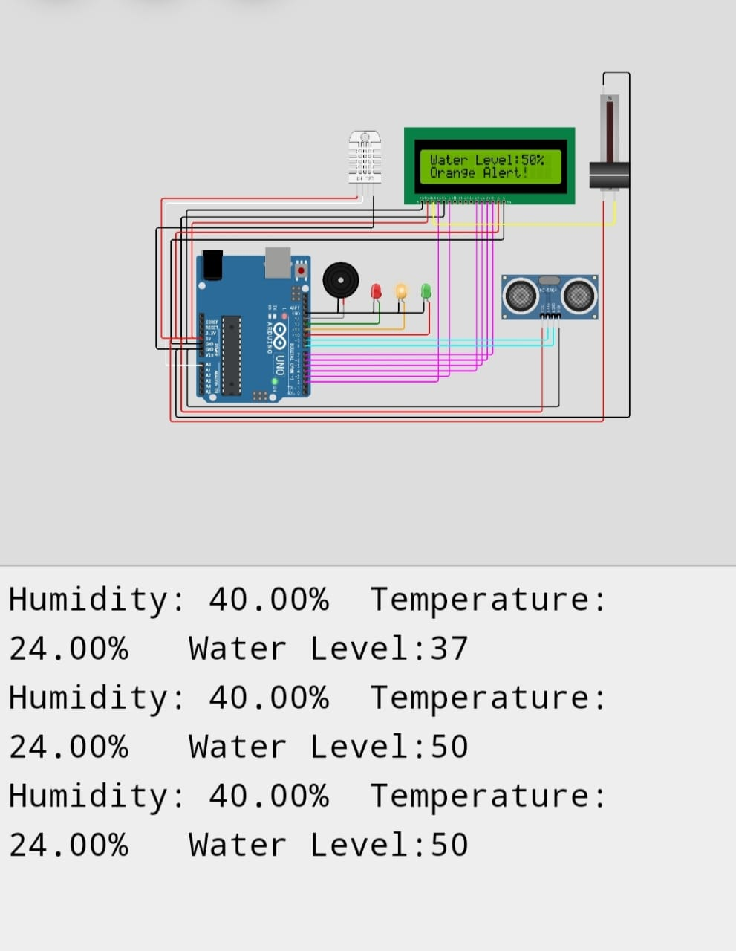

Conclusion:

**In conclusion, the use of IoT for flood monitoring is a highly effective and promising solution. It enables real-time data collection and analysis, enhancing early warning systems and disaster management. By deploying sensors and connected devices in flood-prone areas, we can significantly improve our ability to monitor, predict, and respond to flood events, ultimately saving lives and reducing the impact of floods on communities and infrastructure. This technology has the potential to revolutionize flood management and improve resilience in the face of climate change and increasing flood risks.**